Club Together

Future Physical re-defines webcast events at 13th Sept Launch

As clubbers across the world dance the night away it may come as a surprise to them that the future is even closer at hand.

shinkansen, established producers of art, performance, media, club culture events and web technology have conceived a project called Future Physical. Backed by East England Arts Board, Future Physical is exploring future interaction of the human body and technology through a series of pioneering events and art commissions. Future Physical supports internationally established artists to relative newcomers, all with the imagination to envisage a remarkable path into the future, pushing the boundaries of technology while blending it with art.

The first series of Network Exchange events under the banner WEAR ME!!! focuses on wearable computing and smart textiles. Through a series of events and commissions Future Physical will help people discover how digital technology is being integrated in to our clothing. How will future clothing affect the way we work and play together? What exciting evolutions in technology will give us easy to wear, fashionable and portable digital technology on the move?

The project launched in September 2002 where Future Physical, working with web streaming specialists Groovy Gecko, pulled off a stunning coup in UK club culture. Successfully combining performances from 3 different locations (Norwich, London and Colchester) in the UK’s first 3 way web-streaming event which was subsequently mixed down in to one broadcast (much like a live TV show with multiple camera angles). This meant each event’s producers could pick and choose from feeds from each of the other two events to create their own unique event.

One of the commissions, Cellbytes, demonstrated the potential of the technology by having dancers in London and Norwich perform together through a series of screens and camera feedbacks.
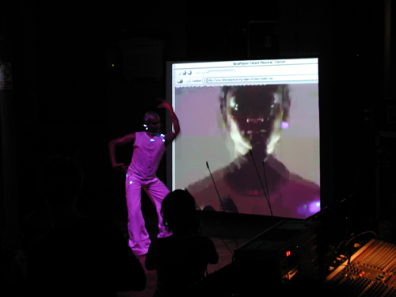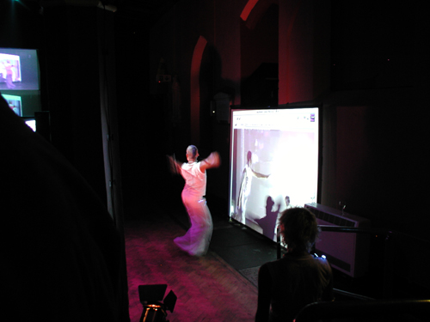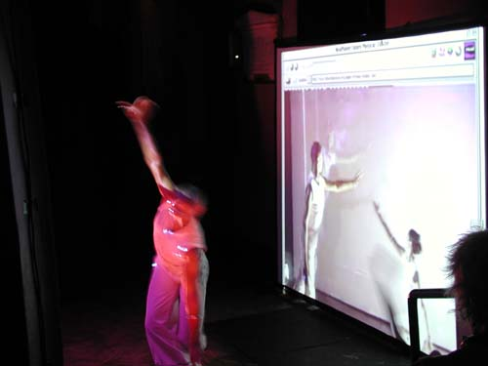

And in true clubbing spirit the cameras were then turned on the audience so the crowds in London and Norwich could mingle, wave and party together…

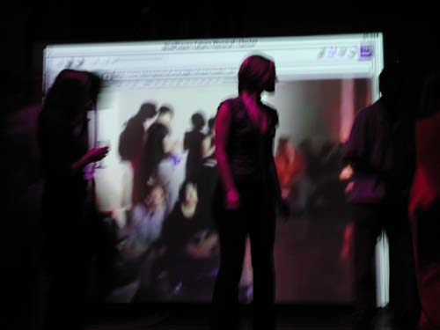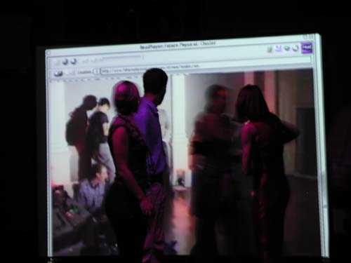

The idea of ‘webcasts’ as we know them has been around for a few years – from the early attempts at broadcasting live footage of concerts and clubnights to the internet back in the 90’s but the actual concept, called ‘Telematics’ has been around in one form or another since the 1960’s. It didn’t start with Rosswell and aliens but rather an understanding within art and science circles that technology would sooner or later bring us together in new and unusual ways. An obvious spin off has been the development of remote medical procedures where a surgeon can operate on a patient from many thousands of miles away.

Better still, the concept of Telematics has recently been made famous by the recurring Red Square vodka television advert where a guy dancing in a club, stares at a screen where a girl is dancing on a beach. Cut to the beach and a girl is staring at a laptop where she can see the guy in the club staring at her. We never see them fall in love and have 2.5 children but the understanding is that this is a relationship fuelled by interaction between two places through the internet. Telematics doesn’t just stop there, it goes further to propose actual interaction between two places – work together, speak to each other, dance together, feel each other…

Don’t rush down to Tandy’s just yet though, there is still much to do, the technology just hasn’t been designed ‘to do this’ – standing at the event you could almost expect to see Star Trek’s Chief Engineer Scotty surface from the high-tec / low tec combination of cameras, cables, computers and mixing desks to shout ‘she canna take it captin’!’ One of the producer’s at the Norwich event bemoaning the very technology they rely on. “The Mac has an output designed to send a video feed out to the projector and plasma screens and you’d expect it to work, but one of our guys has had to totally reconfigure the Mac to get it to pump out the signal we need.”

Plug and Play – Plug and Pray rather…at one point the signal goes down – it’s not their fault, the advanced facilities just can’t cope with the sheer demand on their internet bandwidth, even though they’re supposedly geared up for this kind of event – so they have to choose between sound or pictures at one point. Perhaps the venue’s designers didn’t count on the sheer amount of material being pushed backwards and forwards between these revolutionary types of events. Next up the Mac in Norwich receiving the video feed from London stops outputting it through ‘that’ plug to the screens so the low tech solution comes in – point a video camera at the Mac’s computer screen showing the footage from London and send the image in the old fashioned way…

It’s the end of the night, and the audience is breathless, they’ve seen ground breaking performances from Ambienttv.net, Raya, Bedouin Ascent, Cellbytes, Sureshot and danced with their London counterparts to London Elektricity DJ’s and headliners the Neutrino’s. Each and everyone of them will go home with a story to tell, one that might just surprise their friends, and no doubt provoke disbelief but next time you see someone on a screen in a club, try waving, they might just wave back.

WEAR ME!!!

The WEAR ME!!! Network Exchange programme involves a Wearables Marketplace at The Forum on Saturday 7th December for the public to view new smart clothing and digital accesorries, and test prototypes and experiments by artists and industry.

WEAR ME!!! also brings the txOom PlaySpace by international art/science collective Fo.AM to Great Yarmouth and the Hippodrome Circus Space, from 1st-7th December. Inside txOom, participants (from aged 5yrs upwards) can play with visuals, tangle in textiles and influence the music and video environment around them by the way they move and interact with the space. An intriguing glimpse at the things to come in the world of interactive spaces and intelligent garments using body sensing technologies and active fabrics.

Notes to editors
Future Physical: Stretching technology - a human adventure
Future Physical is a major cultural programme exploring the changing boundaries between the body and technology. Future Physical places the human body at the centre of digital interaction through commissioning and presenting regional, national and international projects and events specially designed to creatively push forward the scope and scale of our physical interactions with everyday technologies: within the four research areas of Future Physical: Wearable Computing and Smart Textiles, Bio-Technology, Eco-Technology and Responsive Environments.”

The programme of projects and events will be taking place between December 2002 and April 2003 – timings and venues will be announced at a later date.

East England Arts is the Government development agency for the arts in Bedfordshire, Cambridgeshire, Essex, Hertfordshire, Norfolk, Suffolk and the unitary authorities of Luton, Peterborough, Southend-on-Sea and Thurrock. Its mission is to increase the impact of the arts in East England. It does this by making strategic investments in the arts, by providing advice and expertise, and by working in partnership with other agencies and stakeholders, especially Local Authorities. During the life of its current Corporate Plan 2000-2004 East England Arts is investing £30 million of public funds in the region’s arts.

shinkansen is an artist led cultural research and production unit specialising in the performative use of digital technologies. The unit has specialist skills in collaboration, interauthorship, networked production processes, intelligent stage and telematic performance creation. shinkansen deliver a year round programme integrating professional development and public events at a local to global level. The unit creates performance for live to digital distribution, generating projects that enhance creativity and learning for public and professionals alike.

The three venues were the Institute of Contemporary Arts – London, Norwich Arts Centre and Colchester Arts Centre

